Participants:  Balazs Grosz, Michal Brozyna, Ngonidzashe Chirinda, Jesper Riis Christiansen, Alberto Sanz Cobeña, Janne Korhonen, Attila Machon, Sergiy Medinets, Ana Meijide, Robert Thomas Edmunds Mills, Mari Pihlatie, Ülle Püttsepp, Mark Theobald, Tiina Tosens, Veiko Uri | 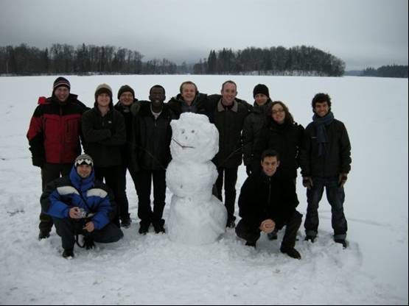

Summary
NitroResolution 2008 was a workshop intended for young scientist involved in NitroEurope IP. The purpose of the workshop was to get young scientists together and discuss current N research challenges, future N research directions, how to communicate within large research projects, such as NitroEurope IP, and come up with ideas how to promote N research to the wider public.
The workshop included plenary and group discussions and focused on answering key questions set by the organisers of the workshop.

The main conclusions of the workshop were that:
- Future N research needs to continue developing and comparing methodologies;
- Themes of future research programmes should include the quantification of pollutant swapping, changing agricultural practices (e.g. biofuel production) and the role of NVOCs in the N cycle;
- Links between other research fields (e.g. aquatic, carbon, socio-economic) need to be established or improved;
- Internal communication within NitroEurope should be improved to give participants a better understanding of the project as a whole and to foster cross-component working;
- More effort needs to be put into engaging the public with the science of NitroEurope.

Workshop objectives

The main objectives of the workshop were to:
- Produce ideas for new future research directions;
- Suggest methods to improve integration within NitroEurope and future projects;
- Develop ways to share the research of NitroEurope with the rest of world.

These objectives led naturally to the three expected outputs of the workshop, which were plan of:
- How to take future directions in N research
- How to improve integration within large projects
- How to communicate the science of NitroEurope with the public

Before attending the workshop, each participant had to complete an application form giving there initial views on the future of nitrogen research, how it can be better linked with other research areas and how nitrogen research can be communicated to the wider world. These responses provided the basis of the five key questions on which the workshop was focused.

Key questions

The five questions below were discussed during the workshop and formed the basis for group work and group presentations.

Q1) What are the current challenges in your field(s) of research and what should the priorities be for future nitrogen research in these fields?
Q2) How can we assess the whole N cycle and not miss important processes, sinks or sources?
Q3) How can we link nitrogen research to other research areas?
Q4) How can we improve the communication within large projects (such as NitroEurope) to ensure a coherent approach to the research?
Q5) How can we engage the wider world (schools, general public, politicians, media etc) with nitrogen research in an “attention grabbing” way?

Before starting to answer these questions, each participant was given the opportunity to give a 5 minute presentation to introduce themselves and their initial thoughts on these five questions. Four groups were then formed and the five key questions were discussed.

Answers to questions Q1 to Q5
The group presentations have been summarized below.

Q1) What are the current challenges in your field(s) of research and what should be the priorities for future nitrogen research in these fields?

This was a challenging exercise for the groups because each group had members from different research areas making it difficult to focus on and discuss individual fields. However, there were several themes that reoccurred in the groups’ conclusions that can be separated into 3 categories: methodological, general and future research challenges.

- Methodological challenges
- Sources and quantification of errors in (chamber) measurements
- The planned chamber intercomparison workshop will go some way to tackling this challenge but there will be some outstanding issues that need to be dealt with e.g. spatial distribution of fluxes and number of sample locations and gas analysis methods
- Standardisation of measurement methods
NitroEurope has gone some way to do this (e.g. the measurement Cookbook) but it was felt that the methods are still not standardised adequately and that differing methods are still used. One suggestion to improve the standardisation of the measurements is to provide checklists for the measurements to ensure that everybody is following the same procedure and recording all the data necessary for analysis.
- Parallel measurements with different techniques
    - Flux measurement methods: chambers, eddy covariance, lab techniques
    - Chamber measurements with “standard chamber” at different field sites

- General scientific challenges
- Up-scaling: How to scale up from soil processes at the plot scale to the European scale?
- Frequency of data collection: Are we missing events? (rain, freeze-thaw etc)

- Future research challenges
- The role of NVOCs in the nitrogen cycle
- Studying the adverse effects of pollutant swapping
- Improve existing theories and models related to N cycling
- How will the interaction between C and N cycling change in changing climate?
- What are the magnitudes of N₂ fluxes?
- What is the role of N-fixation as an input of N into natural ecosystems?
- What is the effect of biofuel production on greenhouse gas emissions in the future?

Q2) How can we assess the whole N cycle and not miss important processes, sinks or sources?
- Multidisciplinarity
- To bring together different scientific disciplines to discuss the scientific problems and try to solve the problems from all directions
- Links with other N research areas (e.g. aquatic)
    - Invited speakers in workshops and annual meetings
- Inclusion of other global regions (e.g. using NGOs)
    - Invited speakers in workshops and annual meetings

This last point highlights the fact that NitroEurope is only dealing with the nitrogen cycle within a small part of the world. Since nitrogen is a transboundary issue, similar research should be encouraged in other parts of the world. This could be done through links to NGOs (such as UNEP) using the experience of researchers from the NitroEurope IP.

- Methodological approaches
- Use different independent measurement methods to assess the problem

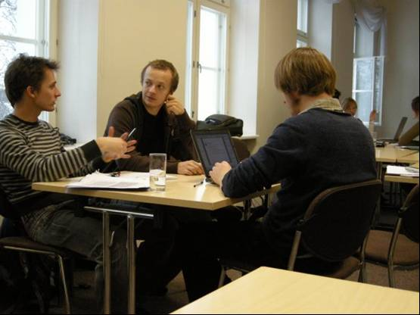 | 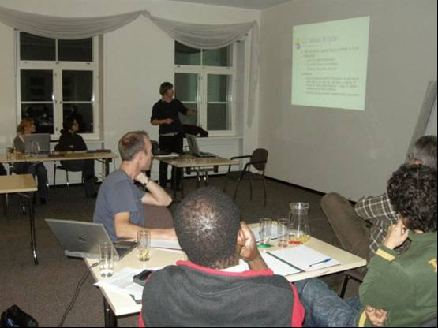

Q3) How can we link nitrogen research to other research areas?
We can’t consider N in isolation
- Link Carbo- and Nitro- Europe through standard techniques, and aims
The average NitroEurope scientist is not up to date with the results of CarboEurope and therefore it is difficult for researchers to see how their work relates to the work done on the carbon cycle. CarboEurope results, therefore, need to be publicised better to NitroEurope scientists
- Try to work towards an integrated approach between terrestrial and aquatic systems
- Measure C and N processes simultaneously
- Working with and understanding socio-economic research related to N (e.g. abatement strategies and effects, population growth)
    - C4 and C5 links, try to make contacts and links with socio-economic research groups..., invite speakers to workshops and conferences

Q4) How can we improve the communication within large projects (such as NitroEurope) to ensure a coherent approach to the research?

Web-based communication
- NitroEurope newsletter summarising the project progress (e.g. quarterly)
It was unanimously agreed that the NitroEurope scientists need to be kept up to date with what is being done outside of their contribution (e.g. component). The best way to do this would be through a project newsletter, which would give a brief summary of recent activities within each component. The groups realised that this would need to be brief (e.g. 1-2 pages), otherwise people would not have the time to read it.
Therefore the suggestion was that each component produces a short paragraph giving a very brief overview of recent activities and any interesting results. Naturally, the discussion turned to whose responsibility the newsletter would be. Since this needs to be coordinated centrally, it should be the responsibility of the project secretariat with input from each component (e.g. through the component leaders). It was recognised that this means additional work but it was agreed that this would enhance cross-component understanding as well as create the feeling of project ‘ownership’ for all project members
- Make the NEU webpage to be more interactive and partly open to public
    - Fully open part of the pages should include information about the project, presentations and other public information
It was felt that the NitroEurope web-portal as a source of information for project participants (news, templates, data etc.) was good but was a poor source of project information for external visitors (policy makers, general public etc.) The web-portal home page has been designed to serve the needs of project participants but does not provide a welcoming introduction to the project for outsiders. It was suggested that a ‘public-friendly’ home page is added to the web-portal instead of the current one aimed at project participants.
- Include an interactive “NitroEurope-Wiki
  - That include list of NEU researchers and their expertise (keywords) + contact info for them

Workshops and meetings
- Collaboration between components (visits to different institutes with aims to write papers together)
- More meetings focused on specific topics (these could be virtual)
- Educate NEU to communicate – we need professional help!
  - Organise a communication workshop
This last point recognises that scientists aren’t often the best communicators and therefore we should make use of professional services to improve communication within the project

YSF based communications
- Interest groups
  - Self-initiated networking within NEU Young Scientists’ Forum to establish a group of similar researchers
- Negotiations needed to secure funding for future workshops (e.g. NEU, ESF etc.)

Q5) How can we engage the wider world (schools, general public, politicians, media etc) with nitrogen research in an “attention grabbing” way?

There was a lot of enthusiasm within the group to develop these kinds of activities. As a result of these discussions it was agreed that the next Young Scientists’ workshop will focus on improving the engagement of the public with nitrogen research.

How to communicate research
- Write articles in local/national newspapers (inc. internet)
- Development of common presentations/posters to be widely disseminated. These should be the responsibility of the NitroEurope ‘Dissemination’ component. The idea is that every project partner is provided with a presentation or poster describing the project, which can be used during open days, science week, school visits etc.
- A public user interface on website (as mentioned above)
- Make documentary films (internet or TV) about the aims, measurements, results of our research (Animation of model results at the European Scale, changes in emissions during the year, if temperature/ precipitation patterns change, etc.)
- Instead of just providing a single ‘end report’ we need to have user specific reports similar to IPCC (e.g. for policy makers, land managers, school teachers etc.)

Practical communication of research
- Interaction with local schools (talks, games, competitions.)
- Science festivals, public shows etc.
- Development of games/ exercises/ activities which get the message of N cycling across to young people in a fun way
- International educational programs (GLOBE) every country can join and share their experiences
- Creation of a YSF school coordination team

This last point was acted on at the meeting and a coordination team was formed that will develop material (presentations, games etc), that project partners can use to bring the science to local school children.

Workshop Conclusions

- Future N research needs to continue developing and comparing methodologies. It was recognised that NitroEurope has gone a long way to standardising methods but this can be improved further (e.g. by the use of measurement check-lists to ensure that all data are recorded correctly);
- It was recognised that a small workshop like this involving researchers from many different fields cannot realistically plan the direction of future research. However, several themes were suggested that need to be investigated further. These included the quantification of pollutant swapping, changing agricultural practices (e.g. biofuel production) and the role of NVOCs in the N cycle;
- Links between other research fields (e.g. aquatic, carbon, socio-economic) need to be established or improved. Work needs to be done establishing links with other research communities so that they can be invited to component and annual meetings
- Internal communication within NitroEurope should be improved to give participants a better understanding of the project as a whole and to foster cross-component working. This could include the use of professional consultants who could hold workshops for scientists to improve their communication methods
- More effort needs to be put into engaging the public with the science of NitroEurope. Many ideas were suggested to accomplish this aim and a Young Scientists’ Forum school coordination team was formed at the workshop to work towards developing these ideas further.

Report prepared by Jesper Riis Christiansen, Mari Pihlatie and Mark Theobald

